MEC4047 Assignment 1

PLAGIARISM declaration

1. I know that plagiarism is wrong. Plagiarism is to use another’s work and pretends that it is one’s own.
2. Each significant contribution to, and quotation in this assignment from the work(s) of other people has been attributed, and has been cited and referenced.
3. This assignment is my/our own work.
4. I have not allowed, and will not allow anyone to copy this work with the intention of passing it off as his or her own work.
5. By filling in my full names, I am formally signing this declaration and declares I have abided by the rules.

Document AUTHOR

| Student Number | Full Names |
| --- | --- |
| FNNDYL001 | Dylan Fanner |

Contents

1. Analytical Solution 3

1.1 Dynamic magnification ratio and phase angle 3

1.2 Analytical solution for transient and steady-state displacement response 4

1.3 Force exerted on floor as function of frequency ratio. 8

# Analytical Solution

This section presents an analytical solution to the vibrating washing machine, including both steady-state and transient elements. The majority of calculations were done using MatLab R2022b, however these calculations and any algebraic derivations done have been transcribed in full in the following sections. Plotted results come from the MatLab implementation or python code.

## Dynamic magnification ratio and phase angle

**Figure 1: Free body diagram of washing machine with unbalanced load**

From the steady state free body diagram, the differential equation of motion for the rotating washing machine is as follows. The omega term is left as a symbolic variable as it can take on multiple values.

To find the dynamic magnification ratio and phase angle, the damping constant needs to be calculated. The frequency ratio as the variable is left symbolic.

Dynamic magnification ratio:

Phase angle:

**Figure 2: Phase angle as function of frequency ratio**

## Analytical solution for transient and steady-state displacement response

Three analytical solutions are presented for cases where the drum speed is equal to 400, 800 and 1200 rpm respectively. Before these values can be used in equations they need to be converted to rad/s:

The steady-state conditions for the washing machine drum and load are a typical case of rotational unbalance and can be found with standard formulae. First, the system values independent of the rotational speed of the drum are found:

The values above are independent of drum rotational speed. All following values differ depending on the drum speed used, and as such the formulae are presented and the final values are shown for each drum speed, but detailed substitutions are not shown for each case.

First the magnitude of the vertical response is calculated based on drum frequency:

Secondly, phase angle of the steady-state response can be found. First find the frequency ratio for the three drum speeds:

Then calculate steady state phase angle, psi:

Combining these two values (displacement and phase angle) shows the steady state displacement response of the washing machine. This is the particular solution to the differential equation of motion established in the first section.

Next is to calculate the transient response of the suspended drum as the rotation begins. Due to the presence of damping, no simple formula exists for the transient response. Derivation is needed to find the coefficients Aand B of the transient response.

Assume the complementary solution is of the form:

Then the full displacement of the spinning drum is as follows:

First substitute in the position at the start time, in this case 0:

Next find the derivative of y and substitute in the velocity at the start time, in this case also 0:

The constants A and B can be solved for any RPM value desired. This solving needs to occur for any RPM as changing the drum speed affects the magnitude and phase angle of the driving force. For 400, 800 and 1200 RPM, the values for A and B and C are shown in the table below. These can be used along with the formula for the full displacement response to plot the displacement response.

**Table 1: Constants for displacement response for different drum speeds**

|  |  |  |  |
| --- | --- | --- | --- |
| **RPM** | **A (m)** | **B (m)** | **C (m)** |
| 400 | 0.0269 | -0.0058 | 0.0273 |
| 800 | 0.0221 | -00032 | 0.0221 |
| 1200 | 0.0213 | -0.0029 | 0.0214 |

lots of these graphs are now shown, as well as an estimate for how quickly the transient response dies away in natural periods for each case.

**Figure 3: Washing machine displacement for 400 RPM.**

**Figure 4: Washing machine displacement for 800 RPM.**

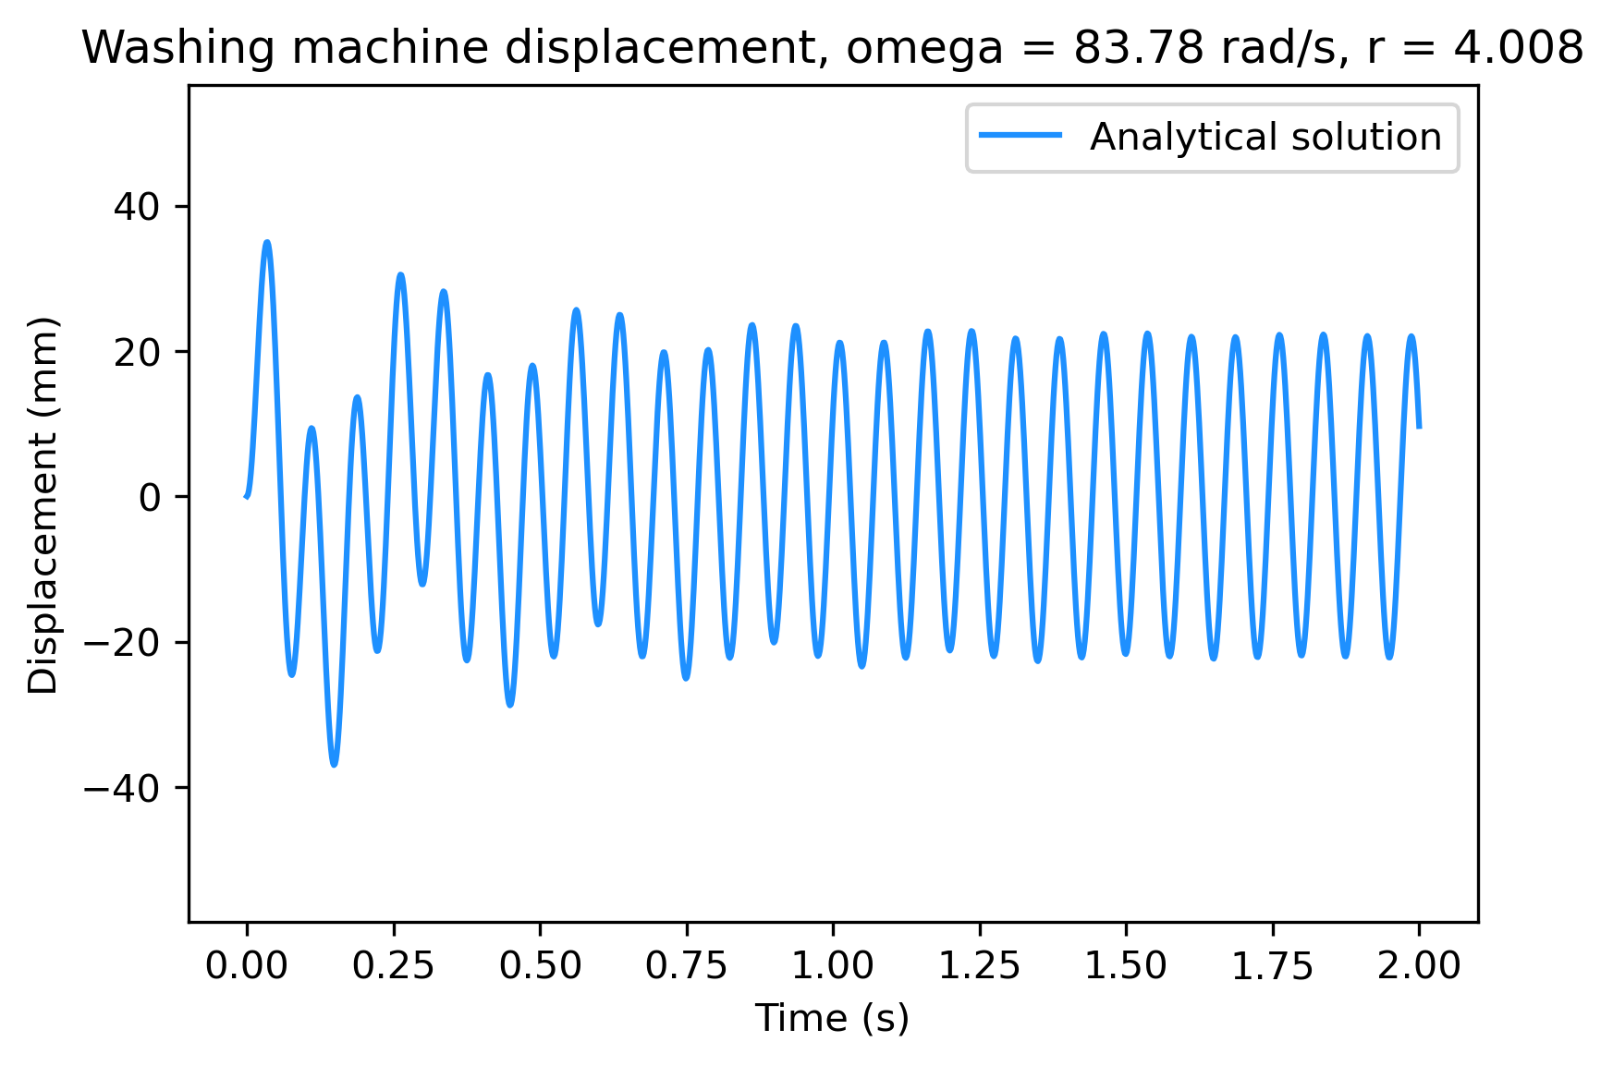

**Figure 5: Washing machine displacement for 1200 RPM.**

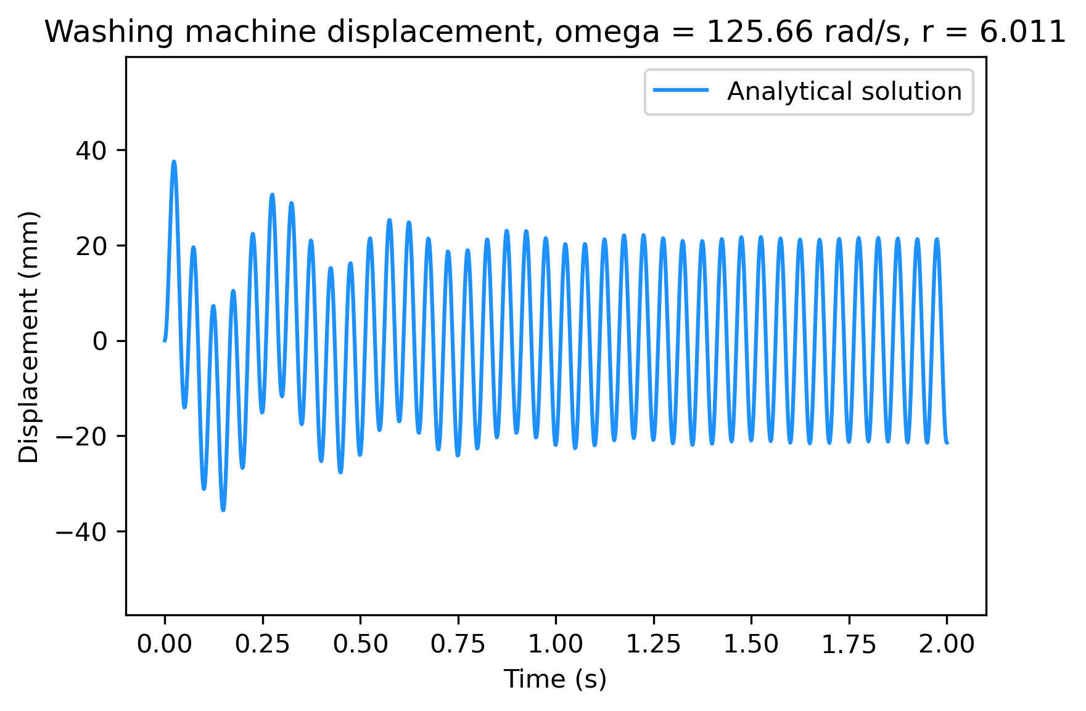

Counting natural periods until the transient response is no longer visible in the output displacement graphs. For 400 RPM it takes approximately 8 natural periods for the transient response to no longer by noticeable. For 800 RPM it takes approximately 17 natural periods and for 1200 RPM the number of natural frequencies increases to approximately 30 before the transient response is negligible.

## Force exerted on floor as function of frequency ratio.

An expression for force exerted on the floor needs to be derived from the displacement function for the washing machine. Due to the force being plotted against frequency ratio, the brief transient response of the washing machine is ignored for this analysis, and only steady state force is found as a function of frequency ratio.

Then the function for force on the floor is given by:

Given that we are looking for magnitude of force only, the cosine can be discarded, and sigma not calculated. For rotational unbalance:

Substituting in , and using MatLab functions for simplification, gives the function for force on the floor due to vibration of the washing machine. Given that r is the only variable, and the only value that varies as the driving frequency is changed, this function will plot the force on the floor as a function of driving frequency.

Evaluating this function with the given parameters for the washing machine, from r = 0 r = 5 gives the following graph for force on the ground as a function of frequency ratio:

**Figure 6: Force on the floor as a function of frequency ratio**

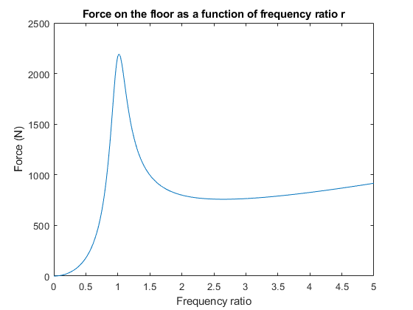

# Python Implementation of Central Difference Approximation

## Implementation and verification

The formula for the central difference approximation was adapted directly from the MEC3075F course notes. Namely, the position is given by:

where

The approximation for from the course notes was not used however and was instead derived from first principles (the given approximation was found to be extremely inaccurate).

Given the assumption:

Based on FBD for drum and suspension:

Then the position one timestep before the starting position can be found:

Implementing this scheme into python gives good results for a variety of simple situations. To test whether the implementation was working, several problems with known analytical solutions were checked. Some of these tests are shown below.

For this undamped differential equation:

With solution:

The central difference implementation produces this result with 200 points over 10 seconds:

**Figure 7: Central difference approximation of undamped harmonic oscillator**

